**Password Reset Through SMS**

**via**

**LocalText.in**

By Vikash Raaj

Contents

Environment Supported. 2

Installation Steps 2

Login page Change 2

Sitecore Client XML Change 2

Package Installation 2

System Settings 3

How to use 4

Demo 4

Code Base 4

Support 4

# Environment Supported.

Currently the installable will support only **Sitecore 9.3**, if you need to make use of the same at some other version, you are required to **download the latest code base from GitHub** and then change the Nuget to download from Sitecore for lower version and then use the same.

# Installation Steps

## Login page Change

* Change the File <Sitecore 9.3 Instance>\sitecore\login\default.aspx line 1 to

<%@ Page Language="C#" AutoEventWireup="true" CodeBehind="Default.aspx.cs" Inherits="Sitecore.Feature.PasswordSms.sitecore.login.Default" %>

## Sitecore Client XML Change

* Change the File <Sitecore 9.3 Instance>\bin\Sitecore.Client.xml by performing search and replace.
  + Search with Sitecore.sitecore.login.
  + Replace with Sitecore.Feature.PasswordSms.sitecore.login.

## Package Installation

Install the provided package in Sitecore Instance as below.

* Password Via Sms Core DB Package-V1.0.zip 🡪Contains all Sitecore item change in Core Db
* Password Via Sms Physical Package-V1.0.zip 🡪 Contains the physical Files to deploy in CD\CD instance of Sc9.3 Version

### System Settings

We need to add the TextLocal.in API details and also the SMS Template that required to send as SMS at provided path, Make sure you create an account in textlocal.in and enable the API Services and use same information in Auth Value and sender ID field in Sitecore.

/sitecore/system/Settings/Security/Password recovery/New Password Recovery Sms

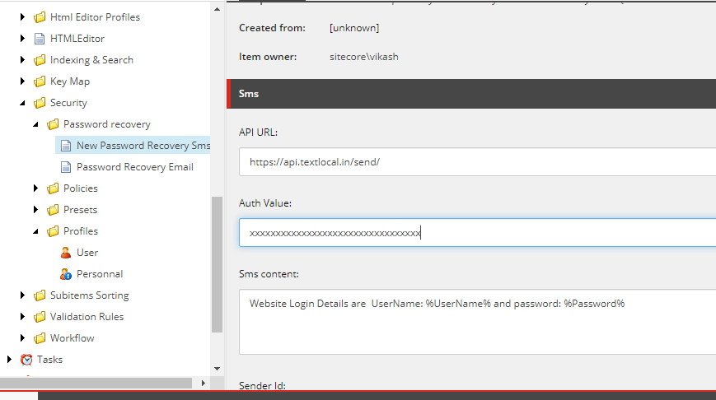

Update all User profiles’s Mobile Number in the Sitecore as below.

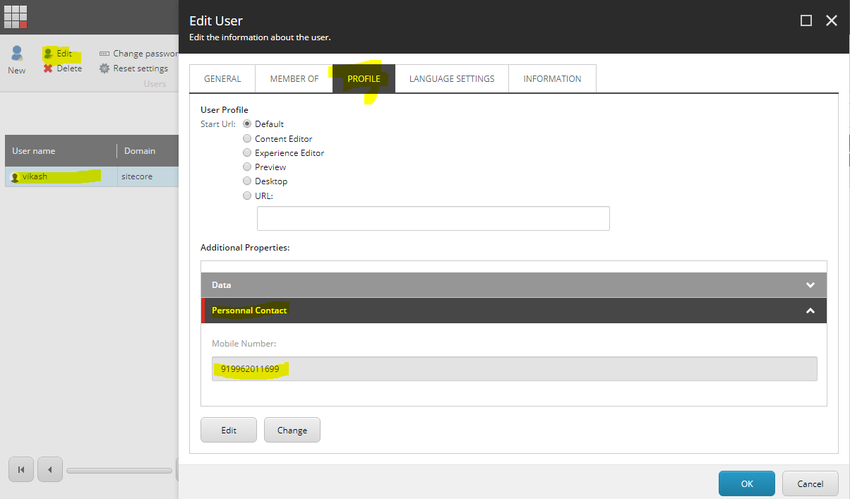

# How to use

## Demo

Open the Sitecore Login page and click forget password link and submit ur login with domain and you can see the window as below

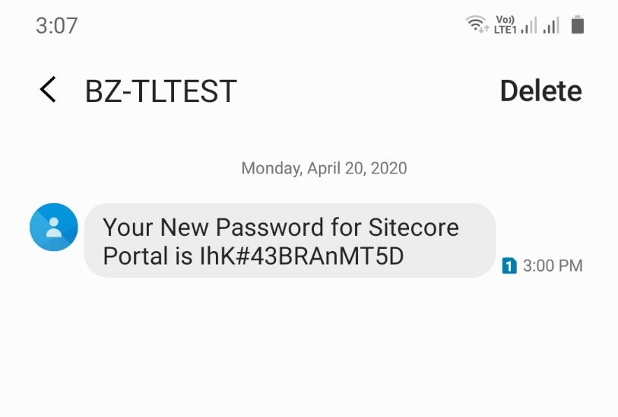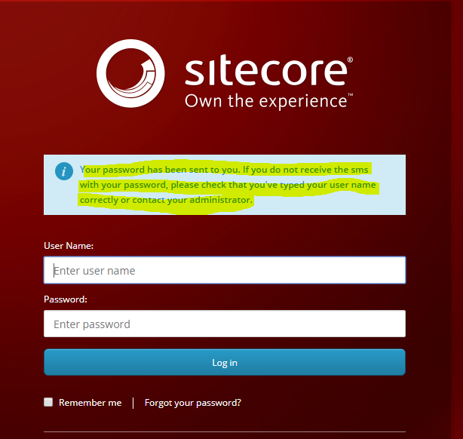

# Code Base

Code has been released as Open source in GitHub @ <https://github.com/vikashinchennai/Sitecore-Password-SMS-Via-LocalText.in>

Changes or upgrade are welcome on the plugin

# Support

Feel free to reach to be in Git or directly for any support or ideas.